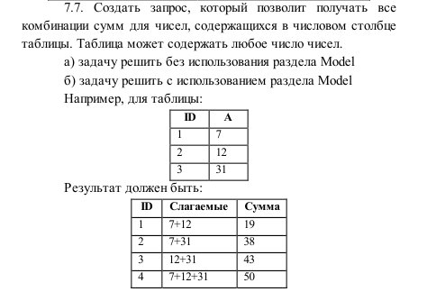

WITH

PLUS AS

(SELECT SYS_CONNECT_BY_PATH(A,'+') AS STR

FROM LAB77

WHERE LEVEL>1

CONNECT BY PRIOR ID<ID),

SUMM AS

(SELECT LTRIM(STR,'+') AS "Слагаемые",

(SELECT SUM(A)

FROM LAB77

WHERE STR LIKE '%+'||A||'%') AS "Сумма"

FROM PLUS

ORDER BY 2)

SELECT ROWNUM AS ID, "Слагаемые", "Сумма"

FROM SUMM;

